OFFICIAL COORDINATION REQUEST FOR
NON-ROUTINE OPERATIONS AND MAINTENANCE

COORDINATION TITLE- Updated 24BON063 MOC WA Shore Control Section Redesign-Extension Request
COORDINATION DATE- 28 November 2024
PROJECT- Bonneville Lock & Dam
RESPONSE DATE-

Description of the problem

02/07/25 Update: USACE reached a contractual agreement with the WA Shore Flow Control Section construction contractor, Northbank. The agreement states that Northbank has officially committed to completing all in-water work and removing all materials/equipment no later than 05 March. The contractor has verbally and unofficially committed to try to do everything in their power to be out of the ladder by 28 FEB but could not contractually commit to this date due to material lead time. With this information, the latest date of complete return to service of the WA Shore Fishway will be 06 March (if the contractor completes all in water work and exits the ladder on 05 March and Bonneville Project takes 1 day to return the ladder to service). Bonneville Project will be completing actions to bring the WA Shore Fishway to tailwater elevation during the last week of February to ensure quick turn-around time from the time Northbank exits to the time the ladder is completely watered up. Work above the water is permitted up to 28 March.
The updated commitments and earlier return to service date of the WA Shore Fishway than originally anticipated allows for more serious consideration of "Alternative Action #1", no action. Under this action, Bonneville would not water up the AFF and attempt to operate the AFF as a trap and haul facility. Bonneville could also cancel utilizing the Cascades Island Fishway Exit as well, due to the labor involved in setting up fish counters in the Cascades Island Fish Count Station and dewatering the Cascades Island Serpentine Section after the WA Shore Fishway is watered up.

12/05/24 Update: Based on the most recent FPOM meeting regarding this MOC, the agreed upon completion date for the WA Shore Fish Ladder Control Section redesign is now 15 March 2025. Northbank has agreed to this date and will have the project completed on or before this date. Furthermore, the ability of boat-based avian and pinniped hazing during this work period is currently being considered.

The Bonneville Powerhouse 2 (PH2) WA Shore Fish Ladder Control Section redesign to replace the existing serpentine section with a vertical slot and orifice control section is scheduled to occur during the 2024 Winter Maintenance period. The contract for this project was awarded 27 September 2024 to Northbank. On 15 October 2024, which was the day of the first pre-construction meeting, a protest was filed and Northbank was ordered to stop work until the protest was resolved. The protest was withdrawn by the filer on 19 November 2024. The original in water work period was scheduled to begin following the dewatering of the ladder, and to be completed by 23 February 2025. The
contractor originally concluded that they would need at least 74 workdays to complete the scope of work. The contractor required at least three months prior to the ladder dewatering period for material procurement, fabrication, and preparation; However, due to the now rescinded protest, the contractor and the work period have become significantly delayed in the preparation required for this redesign.

As a result of these events, the contractor now requires until 15 March 2025 to complete the scope of work required for this redesign, which will conflict with the beginning of Fish Passage Season, 01 March 2025. The two-week extension of the project would result in the further extension in the outage of the WA Shore Fish Ladder, and in turn, the inability of fish passage through this route during the work window. Powerhouse 1 (PH1) is the priority powerhouse for both hydroelectricity and fish attraction for upstream migrants while the WA Shore Fish Ladder is out of service (OOS). Currently, PH1 has three operational units due to the extended outages of Main Units 2, and 5-10. In the month of March 2025, PH1 will remain the priority powerhouse for Fish Passage Season until the completion of the WA Shore Flow Control Section Redesign construction and return of service of the WA Shore Fishway. PH1 is expected to have at least two additional units returned to service by 01 March 1, 2025 (Units 6 and 10), resulting in PH1 having 5 operating units.
This redesign project is being completed to improve upstream passage for Pacific Lampreys and reduce passage delay for adult salmonids and is a component of the preferred alternative identified in the Columbia River System Operations (CRSO) Environmental Impact Statement (EIS) and the 2020 Columbia Basin Fish Accords. The new vertical slot and orifice style baffles have been successfully implemented at both Ice Harbor and John Day dams and are designed to improve hydraulic conditions for both Pacific Lampreys and salmonids, while also reducing the distance fish need to swim compared to the current serpentine section. Additionally, this project includes replacing all PIT tag antennas within the control section, resulting in greater counting efficiency.

Recognizing both the potential significant impact to fish passage due to this extension of the work period, and the necessity for the completion of this redesign project for improved passage for Pacific Lamprey and Pacific salmonid species, USACE, including Bonneville Fisheries, have been looking into every possibility to accelerate the schedule by ensuring that all USACE team members prioritize the submittals, as well as increasing the meetings with the contractor during the submittal process, and having the contractor work night shifts during the work period, when feasible. However, despite USACE efforts to prevent further delays and accelerate the project schedule as much as is feasible, the curing window required for the concrete installed within the fish ladder is a timeline that cannot be reduced or accelerated.

Bonneville Project is also actively repairing the crowder and brushes at the Cascades Island Fishway Fish Count Station to provide proper counting facilities while utilizing the Cascades Island Fishway Exit for fish migrating on the north side of the Bonneville Spillway. Additional efforts to protect fish during this time include: beginning pinniped and avian hazing on 01 March rather than the normal 01 April start date, CRITFC boat-based hazing upon regional fish manager’s discretion, and initiating FFU pinniped monitoring on 01 March to provide daily abundance estimates and modified predation monitoring as determined necessary by FFU staff and regional input.
01/07/25 Update:
Per the December 2024 FPOM discussions, USACE is seeking feedback on Bonneville operations for fish passage under two possible concerning scenarios. The two scenarios are:

Scenario 1: If either of the following criteria are met during 01 – 15 March timeframe an action will be taken:

- Daily fish counts provided by the FPC exceed the 15-year daily average (See Table 1) for three consecutive days.
AND

- FFU Pinniped monitoring observes 5 pinnipeds actively hunting in zones 1-7 of PH2 on 3 consecutive days.
FFU will provide daily email update to FPOM interested parties that will include daily average fish count, if the criteria were exceeded, pinniped monitoring observations and if criteria is exceeded. This reporting would begin March 1 and continue until the end of the Washington Shore work.
Scenario 2: If construction work requires the WA Shore Fishway outage extension to extend beyond 15 March an action will be taken.

Table 1. Bonneville Dam daily fish count averages in March (2010-2024) for salmonids and steelhead.
 | Total Chinook | Coho | Sockeye | Steelhead
Mar 1 | 1 | 0 | 0 | 41
Mar 2 | 1 | 0 | 0 | 23
Mar 3 | 2 | 0 | 0 | 25
Mar 4 | 1 | 0 | 0 | 30
Mar 5 | 1 | 0 | 0 | 27
Mar 6 | 1 | 0 | 0 | 30
Mar 7 | 2 | 0 | 0 | 29
Mar 8 | 1 | 0 | 0 | 23
Mar 9 | 2 | 0 | 0 | 29
Mar 10 | 4 | 0 | 0 | 42
Mar 11 | 4 | 0 | 0 | 41
Mar 12 | 4 | 0 | 0 | 40
Mar 13 | 2 | 0 | 0 | 37
Mar 14 | 3 | 0 | 0 | 51
Mar 15 | 4 | 0 | 0 | 57
Mar 16 | 6 | 0 | 0 | 58
Mar 17 | 3 | 0 | 0 | 52
Mar 18 | 6 | 0 | 0 | 51
Mar 19 | 7 | 0 | 0 | 55
Mar 20 | 8 | 0 | 0 | 40
Mar 21 | 10 | 0 | 0 | 48
Mar 22 | 9 | 0 | 0 | 47
Mar 23 | 10 | 0 | 0 | 59
Mar 24 | 14 | 0 | 0 | 67
Mar 25 | 14 | 0 | 0 | 54
Mar 26 | 19 | 0 | 0 | 50
Mar 27 | 27 | 0 | 0 | 52
Mar 28 | 33 | 0 | 0 | 53
Mar 29 | 42 | 0 | 0 | 56
Mar 30 | 31 | 0 | 0 | 53
Mar 31 | 44 | 0 | 0 | 50

If the above concerning scenarios do not occur, Bonneville will continue to operate in the following manner:
- PH1 will remain the priority powerhouse until the WA Shore Fishway has completely returned to service.
- The PH2 Corner Collector (B2CC) will operate per FPP criteria per Section BON 2.3.2.5.v
  - FPP Guidance:
    - March 1 - 8: Open the B2CC daily from 0600-1000 HRS. Open within 30 minutes of the start time and shift the closure time as necessary to maintain the 4-HR duration.
    - March 9 - 25: Open the B2CC daily from 0600-1000 and from 1600-2000. Open within 30 minutes of the start time and shift the closure time as necessary to maintain the 4-HR duration.
    - March 26 - August 31: Beginning at 0600 on March 26, operate the B2CC continuously (24-HRS) through August 31. Close the B2CC within 1 hour of the end of summer spill on August 31.
    - September 1 - April 9: During spill that occurs outside juvenile fish passage season, open the B2CC if available to provide a surface passage route.
- PH2 will pass the remainder of total river flows, following FPP Priority Order criteria found in Table BON-13.
- Spill will only be used upon a “forced” basis due to lack of capacity in all available units at both PH1 and PH2.

The five alternatives for operations proposed by the region if either of the above two scenarios occur are listed below in no order of preference:

- No Action
  - Continue operating PH1 as the priority powerhouse during all hours.
  - Continue operating the B2CC per FPP guidance.
  - PH2 units will be run according to their priority order found in FPP Table BON-13 to pass the remaining total river flow.
  - Spill will only be used on a “forced” basis due to lack of capacity in all available units at both PH1 and PH2.
- Shift B2CC operation from FPP operations to 24/7 operation (continue with all other actions listed above in Alternative 1(a, c and d).

- Limit PH2 generation to the extent feasible during daytime hours (as outlined in 2024 FPP BON Table-5) and spill the remainder of project outflow to maintain the Chum salmon tailwater elevation criteria.
  - PH1 will remain the priority powerhouse during all hours.
  - Reduce PH2 generation to the extent feasible during daylight hours (2024 FPP Table BON-5) to deter fish from entering the PH2 tailrace where the WA Shore Fishway will remain OOS.
  - If applicable, spill remainder of Project outflow to maintain chum tailwater elevation.
    - Assuming a minimum of 125 kcfs total river flows during this period (120-130 kcfs for maintaining chum operations), Bonneville expects a minimum spill of approximately 48 kcfs during daylight hours if 5 Units are available at PH1 and 35 kcfs if 6 Units are available at PH1 (without generation at PH2).
    - The 10-year average BON outflows for 1-15 March are 176 kcfs (range 113-282 kcfs) and for 16-30 March is 193 kcfs (range 116-434 kcfs), 2010-2024. These average flows would equate to an estimated spill volume between 93-106 kcfs between 1-15 March and 110-123 kcfs between 16-30 March if generation was zero at PH2 and B2CC was operating 24/7 at 5 kcfs of surface spill.
    - Current NWRFC Bonneville Dam inflow forecast for the month of March (https://www.nwrfc.noaa.gov/stp/station/stpplot/stpplot.cgi?BONO3) ranges between a low of 120 kcfs and a high of 135 kcfs. Additional forecasting tools and updates will be available
    - Total Dissolved Gas (TDG) considerations:
      - TDG will be monitored at the Warrendale gage (WRNO).
      - TDG will be primarily influenced by the spill and powerhouse flow rates. The B2CC and Ice and Trash Sluiceway also produce elevated TDG.
      - The TDG criteria is 110%. TDG will reach 110% at approximately 70 kcfs spill.
      - When TDG exceeds 110%, we will need to reduce spill or coordinate with ODEQ / Ecology. Previously, both agencies have allowed March TDG to exceed 110% for planned fish passage operations on the lower Columbia River.
    - On average, Bonneville can spill up to 150 kcfs before reaching 125% TDG and erosion concerns at the project, directly downstream of the spillway, along the apron, are minimized.
    - Coordination is ongoing with RCC to determine proper special river operations during this timeframe.
    - Continue coordination with BPA to determine the feasibility and extent possible of limiting PH2 operations to meet transmission reliability and power demand within Balancing Authority, while mitigating for the operation and maintenance of the project.
  - Utilize generation of PH2 during nighttime hours (2024 FPP Table BON-5) while fish migration activity is lowest.

- Operate the Adult Fish Facility (AFF) as a trap and haul facility
  - Place bulkheads near UMT/WA Shore Fishway Junction to isolate workers in the WA Shore Flow Control Section from an active fishway.
  - Test operation during the last week of February to determine if operating the ladder and AFF in this manner meet flow requirements.
    - At 1 ft of ladder head, the AFF lower ladder requires 37 cfs and WA Shore Fishway requires 85 cfs.
    - Utilizing Valve 2 at the AFF and the AFF ladder flows to provide water to the WA Shore fishway (between the AFF and Fish Unit aux water supply within the fishway) is expected to result in 74 cfs in the main WA Shore Fishway (0.87 ft of ladder head).
  - Utilize CRITFC personnel to operate the AFF in a trap and haul capacity.
  - Utilize 1-2 Corps qualified personnel to handle rigging and crane operations during movement of the fish transport tank in and out of the AFF.
  - Potential issues requiring further discussion and review are:
    - Trap and haul procedures, including:
      - Holding time allowable in transport tank
      - Monitoring of anesthetized fish
        - Held in transport tank with other anesthetized fish to recover?
        - Monitoring?
      - Handling of by-catch
      - Transport of fish from sample tank to transport tank

- Operate the UMT backwards to route fish migrating up the WA Shore Fishway to the Cascades Island Fishway Exit.
  - To maintain 1 ft ladder head in the WA Shore Fishway, water level would need to be at 68 ft elevation at WA Shore Fishway weir 67 (the first downstream weir from the UMT Junction).
  - To achieve the above WA Shore Fishway criteria, Cascades Island Fishway/UMT Junction water level will need to be at 68 ft elevation.
    - The nearest downstream weir of the CI/UMT Junction is Weir 66. Therefore, the CI ladder head would be over 2 feet to maintain proper ladder head at the WA Shore Fishway.
  - This option requires a specific bulkhead above the UMT/WA Shore Fishway junction. A bulkhead of these measurements has not been located at Bonneville, any NWP dams, or any NWW dams. Without this bulkhead, this option cannot be used or even tested, due to HECP requirements and the safety of the workers in the WA Shore flow control section.

Additional operations to be implemented during this 01-15 March timeframe are:
- Early USDA Wildlife Services pinniped hazing beginning on 01 March, focused at the PH2 tailrace.
- Use of CRITFC boat-based pinniped hazing.
- Increased FFU pinniped monitoring for abundance and potential predation monitoring prior to the 20-animal trigger, if warranted.
- Use of the Cascades Island Fishway Exit to pass fish migrating up the Cascades Island Fishway.

Type of outage required:
The WA Shore Fishway serpentine section and exit will remain OOS until construction of the flow control section is complete. The WA Shore Fishway entrances may be in use, depending on AFF operation.

Impact on facility operation (FPP deviations):
Outage of the WA Shore Fish Ladder during the first 15 days of Fish Passage Season (01-15 March), resulting in delay/obstruction to fish passage at the Washington Shore during this work window. The Cascades Island Fishway Entrance, B-Branch Fishway Entrance, and PH1 Collection Channel Entrances will remain open and operational during this time frame.
Use of the Cascades Island Fishway Exit.
Potential use of spill to pass excess total river flow during daylight hours.
Potential limiting of PH2 generation during daylight hours.
PH1 will remain the priority powerhouse until WA Shore Fishway construction is complete. Typically, PH2 becomes the priority powerhouse starting 01 March.
Impact on unit priority
PH1 will be the priority powerhouse during this work period, which will not impact unit priority until the start of fish passage season on 01 March when PH2 is supposed to become the priority powerhouse. Units at each powerhouse will be run in their designated priority order with the exception of the 5 Units at PH1, that will likely still be OOS.

Impact on forebay/tailwater operation
None expected according to 10-year averages of total river flow. However, weather and climate conditions may vary, resulting in higher or lower than average forebay/tailwater elevations.

Impact on spill:If necessary and feasible, spill may be utilized during daylight hours to pass excess flow while PH2 is not generating. During nighttime hours, PH2 will operate, and spill will cease.

Dates of impacts/repairs
Extension of Washington Shore Fishway Outage: 01 – 15 March

Length of time for repairs
IWWP (01 DEC – 28 FEB) + 01 – 15 March
Analysis of potential impacts to fish

- 10-year average passage by run during the period of impact for adults and juvenile listed species, as appropriate for the proposed action and time of year:

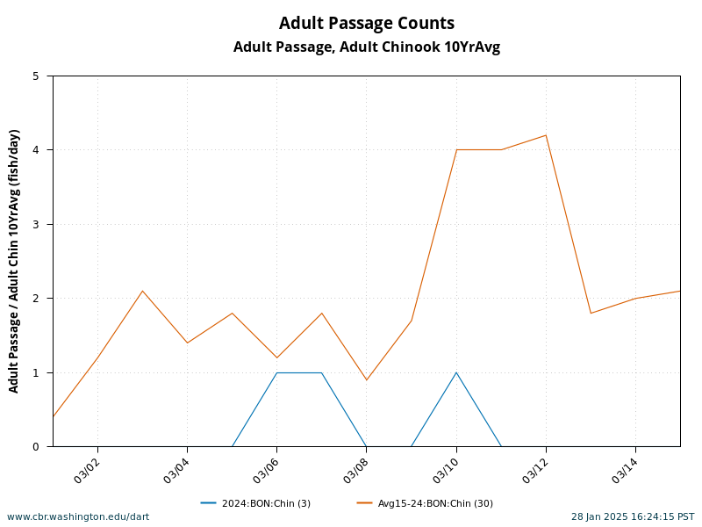
Figure 1. Adult Chinook 10-year average and 2024 run passage numbers for work period 03/01-3/15. Figure acquired from DART.
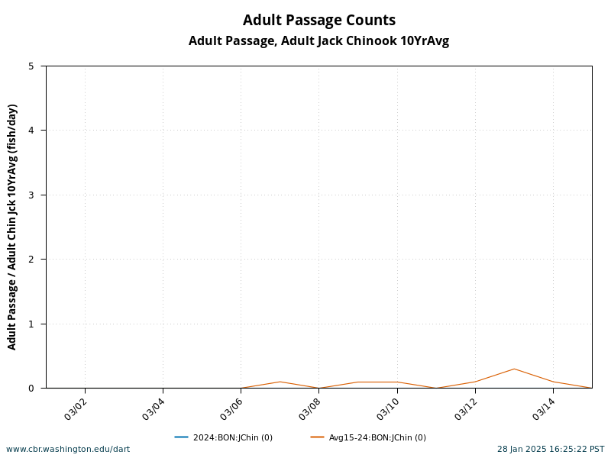
Figure 2. Jack Chinook 10-year average and 2024 run passage numbers for 03/01 – 03/15. Figure acquired from DART.
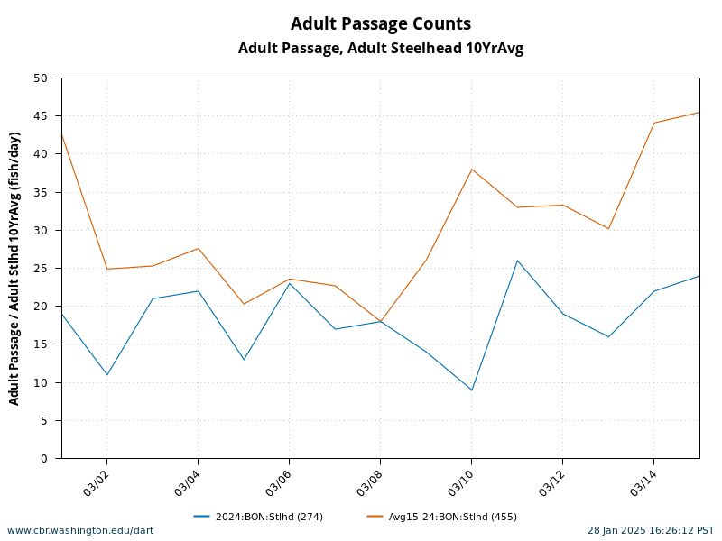
Figure 3. Adult Steelhead 10-year average and 2024 run passage numbers for 03/01 – 03/15. Figure acquired from DART.
- Statement about the current year’s run (e.g., higher or lower than 10-year average):
- Chinook (Total Year Run): The 2024 run of all Chinook runs combined at the year to date (YTD) of this MOC is 648902, which is slightly more than the 2015-2024 ten-year average of 640524. However, this is with the caveat that the current year’s (2025) counts have yet to occur.
- Spring Chinook: The 2024 run of Spring Chinook, which is the run that will be passing through BON during the proposed work window, at the YTD of this MOC is 91,579 for the dates 3/1-5/31 according to the DART historical run times of Spring Chinook. This is below the 2015-2024 ten-year average of 105487.9. WDFW’s 2025 expectation forecast estimates are 122,500 upriver spring Chinook total which is above the ten-year average at BON (105,487) but 88% of 10-yr average return calculated by U.S. v. OR TAC (see run forecast posted by WDFW on 20 DEC 2024).
- Steelhead: The 2024 run of Steelhead at the YTD of this MOC is 181,586, which is slightly higher than the 2012-2023 ten-year average of 150,984.7.
- Estimated exposure to impact by species and age class (i.e., number or percentage of run exposed to an impact by the action);

Table 2. 10-year averages for the work period and percent of the total run affected numbers acquired from DART. Ten-year averages are from the 2015-2024 range.
Species | 10-year average for work period* | Total run 10-year average | % of run affected
Chinook | 31 | 640524 | 0.0048%
Jack Chinook | 2.7 | 84758.8 | 0.0032%
Steelhead | 466.5 | 136573.4 | 0.34%
Sockeye | 0 | 343803.1 | 0%
Lamprey | 0 | 40465.2 | 0%
*Work period is March 1-15

Table 3. 10-year averages by ladder (Washington Shore and Bradford Island) for work period dates 03/01-03/15. Ten-year averages are from 2014-2024 range using FPC query data.
Ladder | Year | Adult Chinook | Jack Chinook | All Steelhead
Washington Shore | 2024 | 2 | 0 | 206
Washington Shore | 2023 | 0 | 0 | 99
Washington Shore | 2022 | 2 | 4 | 578
Washington Shore | 2021 | 4 | 0 | 180
Washington Shore | 2020 | 2 | 0 | 352
Washington Shore | 2019 | 0 | 0 | 29
Washington Shore | 2018 | 2 | 0 | 256
Washington Shore | 2017 | 7 | 0 | 298
Washington Shore | 2016 | 19 | 0 | 574
Washington Shore | 2015 | 121 | 2 | 472
Washington Shore | 2014 | 0 | 0 | 577
10-Year Average |  | 14.45 | 0.55 | 329.18
Bradford Island | 2024 | 1 | 0 | 68
Bradford Island | 2023 | 0 | 0 | 94
Bradford Island | 2022 | 2 | 1 | 85
Bradford Island | 2021 | 1 | 0 | 93
Bradford Island | 2020 | 13 | 0 | 139
Bradford Island | 2019 | 1 | 0 | 43
Bradford Island | 2018 | 0 | 0 | 114
Bradford Island | 2017 | 2 | 0 | 343
Bradford Island | 2016 | 10 | 1 | 252
Bradford Island | 2015 | 117 | 0 | 257
Bradford Island | 2014 | 2 | 0 | 229
10-Year Average |  | 13.55 | 0.18 | 156.09

Table 4. 2024 Fish Ladder usage reported as fish counts and percentage of use for work period of 03/01-03/15. Bradford Island Ladder is shown as “BI” and Washington Shore Ladder is shown as “WA Shore”. Pct is the percentage of passage utilization for that ladder, # is the number of fish that passed the ladder in that day.
*Note: During this timeframe of 2024, PH2 was the priority powerhouse.
Date | Chinook |  |  |  | Jack Chinook |  |  |  | Steelhead |  |  |  | Spill Pct (Middle) | Outflow (kcfs)
Date | BI |  | WA Shore |  | BI |  | WA Shore |  | BI |  | WA Shore |  | Spill Pct (Middle) | Outflow (kcfs)
Date | Pct | # | Pct | # | Pct | # | Pct | # | Pct | # | Pct | #
3/1/2024 |  | 0 |  | 0 |  | 0 |  | 0 | 31.6 | 6 | 68.4 | 13 | 1.2 | 141.6
3/2/2024 |  | 0 |  | 0 |  | 0 |  | 0 | 18.2 | 2 | 81.8 | 9 | 1.2 | 140.3
3/3/2024 |  | 0 |  | 0 |  | 0 |  | 0 | 4.8 | 1 | 95.2 | 20 | 1.3 | 130.7
3/4/2024 |  | 0 |  | 0 |  | 0 |  | 0 | 36.4 | 8 | 63.6 | 14 | 1.3 | 132.9
3/5/2024 |  | 0 |  | 0 |  | 0 |  | 0 | 46.2 | 6 | 53.8 | 7 | 3.5 | 131.4
3/6/2024 |  | 0 |  | 1 |  | 0 |  | 0 | 30.4 | 7 | 69.6 | 16 | 1.4 | 128.6
3/7/2024 |  | 0 |  | 1 |  | 0 |  | 0 | 35.3 | 6 | 64.7 | 11 | 1.1 | 132.6
3/8/2024 |  | 0 |  | 0 |  | 0 |  | 0 | 22.2 | 4 | 77.8 | 14 | 1.3 | 131.4
3/9/2024 |  | 0 |  | 0 |  | 0 |  | 0 | 21.4 | 3 | 78.6 | 11 | 1.4 | 125.7
3/10/2024 |  | 1 |  | 0 |  | 0 |  | 0 | 33.3 | 3 | 66.7 | 6 | 1.6 | 119.2
3/11/2024 |  | 0 |  | 0 |  | 0 |  | 0 | 15.4 | 4 | 84.6 | 22 | 1.3 | 131.6
3/12/2024 |  | 0 |  | 0 |  | 0 |  | 0 | 15.8 | 3 | 84.2 | 16 | 1.4 | 136
3/13/2024 |  | 0 |  | 0 |  | 0 |  | 0 | 43.8 | 7 | 56.3 | 9 | 1.5 | 134.5
3/14/2024 |  | 0 |  | 0 |  | 0 |  | 0 | 13.6 | 3 | 86.4 | 19 | 1.1 | 132.2
3/15/2024 |  | 0 |  | 0 |  | 0 |  | 0 | 20.8 | 5 | 79.2 | 19 | 1.3 | 133.9
 | Pct | # | Pct | # | Pct | # | Pct | # | Pct | # | Pct | #
 | 33.3 | 1 | 66.7 | 2 |  | 0 |  | 0 | 24.8 | 68 | 75.2 | 206

- Type of impact by species and age class (increased delay, exposure to predation, exposure to a route of higher injury/mortality rate, exposure to higher TDG, etc.);
Summary statement - expected impacts on:

Downstream migrants
Downstream migration is not expected to be impacted. The PH1 Ice and Trash Sluiceway (ITS), B2CC, and PH2 DSM will be fully functioning according to their FPP designated schedules during this outage.

Upstream migrants (including Bull Trout)
The Bradford Island Fishway and Cascades Island Fishway will be operational in March during the Washington Shore Fishway outage. Fish will have all Bradford Island Entrances available with proper differentials to migrate upstream, as well as attraction flow to these entrances (Spillbay 18, ITS outfall, and Units 1 and 10. The Cascades Island Fishway will utilize Spillbay 1 for attraction flow and proper entrance differentials. Due to the Washington Shore Ladder being out of service, USDA Wildlife Services will be utilized for extensive hazing efforts in the PH2 tailrace throughout March to deter predation below the closed Washington Shore Ladder.

Lamprey
No lamprey passage is expected to be impacted by this extended outage. Lamprey Passage Structures are not watered up until later in the spring. The 10-year average shows no lamprey passage during the month of March.

Comments from agencies

Subject: RE: Emergency FPOM request for BON WA SH contract

Erin,

I have a few calls today already today from FPOM members regarding the extended outage. They have brought up some good questions/comments that will likely be brought up tomorrow:

Biological Concerns:
1. LCR steelhead stock will be most impacted by this extended outage.
2. The situation at PH1 (oil leak investigations and Unit outages) will leave us with 5 Units available max at PH1 in March 2025
U3 should RTS very soon (if no oil leaks are found upon commissioning)
U6 will be dewatered next and is expected to come back in February 2025
U10 fixed blade mods have started as of today, we are hoping to have that RTS by Feb 2025.
U 9, 5, 8, 7, 2 will still be out of service unless our timeline really speeds up here soon.
3. They are very happy to hear we are trying to get hazers starting early in March to concentrate their efforts at PH2. We could also use CRITFC hazers on boats if necessary.
4. NOAA Fisheries is still standing on 15 March being their cut off date.

Contracting Questions:
1. What is the justification of a 31-day extension if Northbank has already been working on this contract?
2. How much work have they completed so far (the amount we would have to pay them for if the contract is cancelled)?
3. What is the current hold up (prep materials? Ordering materials? Other logistics?) 4. If the delay is due to prepping materials, can we have them start working double shifts this week and next week prior to the fishway outage to get their preps on track?
5. Can we have them working double shift through the whole IWWP to reduce the extension?
6. What date are they going to enter the fishway and begin work? My understanding is that they were going to start as soon as we have the WA Shore Fishway dewatered to tailwater. We begin dewatering WA Shore on 03 DEC. I'd say the very latest that we would be down to tailwater is 05 DEC.

Thank you,

-Jeanette

Subject: [Non-DoD Source] Re: FPOM Official Coordination: 24BON063 MOC WA Shore Control Section Redesign-Extension Request, and emergency FPOM meeting for 22 November

Thanks for the update. I understand that we are going to have a special meeting to further discuss.

Please have information regarding the following questions so we can have a fuller discussion and not have to wait for response given the short time frame for this.

- Discussion with budgetary types and see if funding can be placed in the lamprey "lock box" similar to the 20 million, so we can use for the next dewatering and minimize the impacts
- Further discussions about the schedule of this work are needed. With the resolution of the challenge why is there a need for an additional month to complete the work since the start of dewatering is going forward as planned. What materials, fabrication and preparations are limiting to the schedule and can working double shifts be utilized to help reduce the increased time
- While 5 units at PH1 will help that will not be enough to pass the river flows. A unit or 2 at Powerhouse 2 might be acceptable but more than that would draw adults to a powerhouse with no operating adult ladder. Starting March 1 additional spill will be needed to reduce the attraction of adults to B2.
- Can the UMT be run in reverse so WA Shorre South entrances could be maintained and allow for some adult passage? Cascade Island will need to be run and with it some level of adult counting will be needed (video?).
- Additional sea lion hazing will be needed at after March 1 not April 1. A threshold of sea lions could be discussed. Plan for additional boats not just 1.
- Can the project be split across 2 seasons? Get as much done at B2 this winer season but wrap up by March 1 +/- day or 2. Leave out things that can wait (Pit tag detectors). And then do a dual outage to finish the B2 work the next winter season with allowances to start a week earlier and end a week later than the March 1st.
thanks look forward to the discussion on Friday.

Tom Lorz
CRITFC

Subject: [Non-DoD Source] Re: [EXTERNAL] FPOM Official Coordination: 24BON063 MOC WA Shore Control Section Redesign-Extension Request, and emergency FPOM meeting for 22 November

Hi All,

I'm not going to be able to make the 11am call, so I'm emailing my comments.

I'm willing to support a one month extension to the work window to allow the contractor to finish the project. We've been trying to get the control section rebuilt for many years now, and having to wait another three years would be hard to swallow when we're so close to getting it done. Plus of course, not being able to measure the passage improvements in the upcoming acoustic tag study.

Thinking about the affects to Chinook and steelhead from potential passage delays at PH2, having the WA Shore ladder dewatered in March is certainly not great, but I can live with it for three reasons. One, the water is cold in March, so any delayed fish shouldn't suffer any thermal stress. Two, we won't be in spring spill yet, so TDG levels should be reasonable. Three, there usually aren't many pinnipeds at the dam at that time of year, so additional predation mortality shouldn't be very high. I would like to see some additional monitoring for pinnipeds and additional hazing if needed, as pinniped predation does seem to be the biggest risk. And obviously we would need to be extra vigilant about keeping the other ladders in top shape.

Dave

Subject: Draft minutes for the Special 241122 November FPOM meeting to discuss 24BON063 MOC WA Shore Control Section Redesign-Extension Request. The meeting was held via Webex, from 11:00 until 12:00.

Comments:
- Kovalchuk reiterated that the request was for an outage through 31 March. To move forward a commitment is needed.
- Morrill asked if the form work submittal can be expedited. White said that would be on Northbank.
- Conder commented that this isn’t just a delay issue, presence of pinnipeds creates direct mortality risk. Steelhead are present and Spring Chinook 3rd week in March but sometimes they are early. Not supportable for NOAA beyond 15 March. NOAA could mitigate and provide operations from 1-15 March. NOAA does not support going to 31 March.
- Lorz asked for agreement that we can spill after 1 March. Work on spill pattern to decrease fallback issue. CRITFC would be willing to go forward with an extended outage. Lorz asked if they could do a two-week extension.
- Morrill (WDFW) does not support an outage to 31 March but would agree to moving ahead with an outage to 22 March and discuss work to remove early arriving Stellar sea lions. Conder mentioned trap avoidance issues and commented that trapping may not be affective.
- Kovalchuk -reminded that this project is to improve passage for salmon and lamprey. If it does not go forward it will be two more years before improved passage.
- Van Dyke – There has been details shared by regional voices and why it can’t happen. He would need more details before getting authority to support.
- Porter – from the lamprey perspective they want this project to move forward. They are listening and concerned that the funds stay committed to this project when it starts up again and not taken away or used elsewhere. Asked about changing the ladder outage schedules next year.
- Kovalchuk said there is no guarantee, there is a risk.
- Morrill asked when an update from the contractor will be available.
- Kovalchuk said the contractor is asking for extension to 31 March with the Corps commitment that they will shave off every day they can. Otherwise, they will drop the contract.
- Conder commented, can’t you take this back and let them know that FPOM supports 15 March.
- Lorz said If we get agreements on spill and extra hazing. He would agree to push it until 22 March. Kovalchuk said she can pay for extra hazing, but she cannot speak for BPA concerning spill.
- Kovalchuk will take these comments back for discussion and update the group if the project is moving forward, or they are cancelling the contract.

Audio version of this meeting is available at https://pweb.crohms.org/tmt/documents/FPOM/2010/2024_FPOM_MEET/2024_NOV/

24BON063 MOC WA Shore Control Section Redesign-Extension Request - Bonneville Lock & Dam

Comments: WDFW does not support an extension to March 31. Following the FPOM discussion today, 22 Nov. 2024, WA can accept a March 22 extension provided the COE and Northbrook agree this is achievable and all additional actions to minimize any impact on adults as discussed today are implemented.

Charlie
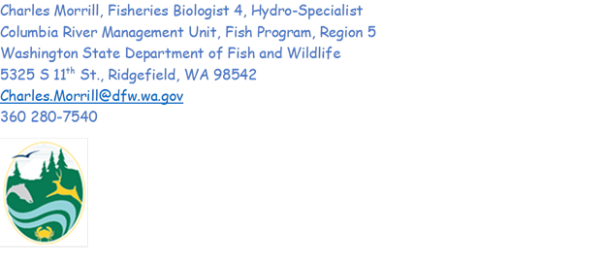

CRITFC/Tribes comments to the MOC - COORDINATION TITLE- 24BON063 MOC WA Shore Control Section Redesign-Extension Request
The CRITFC and Member Tribes Lamprey Projects and others are frustrated and concerned with the potential delay to this project which has been years and millions of dollars in the making and designed to improve passage for both salmonids and Pacific Lamprey. We recognize the difficult position that the USACE was placed under due to the protest which put the project at risk. The USACE was required to set aside 35 days to review the protest. Fortunately, the protest was withdrawn and resolved but left the contractor with a tight turnaround time to implement the project and complete it under the original schedule. We strongly recommend that the USACE pursue a couple of solutions as described in the emergency FPOM meeting. First, we request completion of the project this year as planned through expedited processes described below for the benefit of all fish. We request the Corps find ways to fast track/parallel track implementation and find efficiencies to reduce time on the front and back ends. We support the request to ask the contractor and USACE to find means to shave off one week on both the front end with the Corps and on the back end with the contractor. Delaying it by two years could put the entire project in jeopardy of never being completed, leading to significant loss of funds and staff time being wasted. We are concerned that lamprey projects often take second place to ESA listed species in decision making. However, this specific project was designed to benefit both salmonids and Pacific Lamprey and received support for implementation. We expect robust support from all partners, advocating for this project to be completed with a shortened timeline and guarantee that work is completed no later than between March 16th - March 22nd, 2025. Completing the project during this timeframe will minimize impacts to Spring Chinook and steelhead (based on the passage estimates of anadromous species) and keep the project implementation on schedule within 2024. Several lamprey passage and survival studies (PIT and Acoustic tag) are cooccurring in 2025 (both adult and juvenile/larval) in which it is important to have this project completed to investigate the net impacts of the redesign.
Minimizing impacts to salmonids will be vital and we will work with fish managers and USACE to find solutions. To that end, options including early start-up of Sea Lion hazing (boat and shore/dam face) should be implemented to address the risk of increased predation. In addition, spill patterns to improve passage will need to be discussed and agreed upon (e.g. benefits of leaving one unit “on” at PH2 or not, discussion and agreement on what style spill patterns to use, and existing flat or go for bulk south, etc.). Overall, it will be important to minimize delay or predation on salmonids and lamprey during the extended outage period.
In addition, we concur with the recommendations of the USACE as spelled out in the MOC – that the USACE will be “ensuring that all USACE team members prioritize the submittals, increasing the meetings and communications with the contractor during the submittal process, and having the contractor work night shifts during the work period to reduce overall number of days required.” Bonneville Fisheries is also working to repair the crowder at the Cascades Island Fishway to provide passage for fish using the Cascades Island Fishway. Other indispensable key measures are to begin pinniped and avian hazing earlier than the normal 01 April start date and to coordinate with FPOM to prioritize spill at the other dams in an effort to reduce fall backs. .Finally, in the worst case scenario in which the implementation is postponed for more than one calendar year, we request a strong commitment that the funds will not be lost (i.e. pulled back) or redistributed elsewhere for other projects. We request a well thought out and planned financial resolution to ensure that the funding is locked until implementation. However, in order to reduce unnecessary costs and any potential loss of funding, we ask USACE and the contractor to find means to implement the project within the recommended timeline as noted above.

01/07/2025 Update - discussion and responses:

BPA comments to the MOC - COORDINATION TITLE- 24BON063 MOC WA Shore Control Section Redesign-Extension Request:
BPA – we support maximizing PH1 unit operation and then operating PH2 units closest to the B2CC. We support operating the B2CC as per the FPP. We do not support restricting PH2 generation. We encourage USACE to find a solution that does not require voluntary spill.

Excerpt from the 16 January 2025 FPOM meeting.

8. 24BON063 Updated MOC WA Shore Control Section Redesign-Extension Request (Project Operations 1-15 March)

- Bertrand – This is an overview of alternatives in the MOC. These are draft alternatives and by no means final. The need is to identify break points and add any new information about timelines.
- Bertrand – Actively talking about intricate details of the spill alternative with BPA. One of two scenarios in the MOC that uses the two triggers, high rates of migration and predation events.
- Hausmann – Agree, As the Corps looks at AFF and BPA looks at PH2 limiting generation, feedback on trigger parameters would be helpful.
- Conder – Suggested a 5 pinniped trigger.
- Conder - Pinniped management and monitoring is not sufficient. We will need another alternative such as the AFF, UMT, PH2 flow for fish passage. If the FFU is reluctant to make a call to initiate an action, then five is a good number.
- Wertheimer – We need to understand what the trigger is to develop an effective plan.
- Conder – The trigger indicates we are having an increase in predation at the PH2 tailrace that’s a result of attraction flow at PH2, but no ladder.
- Conder – The AFF plan is still possible, the anesthetic tank could be used, and fish collected. Another point is understanding the UMT option better. Is running 2 ft of head at CI at the UMT exit in order to obtain a foot of head at the downstream weir at Wash shore bad. NOAA would be willing to do this to institute volitional passage. Even if we went just below a foot of head in Washington shore and were not in NMFS criteria. It could still be effective to pass fish. The AFF operation has a lot of complications. If the UMT was doable it would be preferred.
- Lorz – Too much flow is better than not enough, where the AFF seems potentially water deprived. More nervous about the hydraulics at the AFF than at the UMT. CRITFC would need to hire on staff prior to 1 March. How many days a week may determine if two crews are needed. Is there a transmission issue or what is the reason that spilling is out? Is this a physical constraint?
- Hausmann – Being limited to PH1 with the issues there creates issues with the 115 KV line that goes to Hood River vs the 230. Units 1,2,9, and 10 are on 115 and the rest on 230. It matters which units are available. Another thing is the volatility in March, usually have to go seek power. Hard to guess, 10-year averages could be used to predict but it is an uncertainty at that time. The UMT concept sound good but could the project speak to the availability of that bulkhead that would be required above the UMT.
- Hausmann – If the UMT operation was feasible it would trump the AFF operation.
- Morrill – Is on board with the UMT operation if that can be accomplished.
- Van Dyke - Volitional passage is better than added handling of fish.
- Flemmer – If you’re not concerned about the Washington shore fishway being in compliance than we could try it. If they open the fishway they will need to dewater if these options do not work.
- Conder - 15-year daily average for three consecutive days after March 1. Provide passage or AFF, UMT, Daytime flow PH2.
- Morrill will support NOAA recommendation on the ladder criteria.

02/07/2025 update: responses

From: Swank, David R <david_swank@fws.gov>
Sent: Tuesday, February 18, 2025 10:38 AM
To: Madson, Patricia L CIV USARMY CENWP (USA) <Patricia.L.Madson@usace.army.mil>
Subject: [Non-DoD Source] Re: [EXTERNAL] RE: FPOM Official Coordination: 24BON063 Update MOC WA Shore Control Section Work Extension_250210

Hi Patricia,

I don't think using the AFF as a trap and haul is needed now that the ladder will be operational by March 6th. I have some concerns about how fish might be impacted by handling in an operation that the Corps has had little time to set up and zero time to actually test on fish, using a system that was never designed to use as a trap and haul.

Dave

From: Tom Lorz <lort@critfc.org>
Sent: Tuesday, February 18, 2025 11:45 AM
Subject: [Non-DoD Source] Re: FPOM Official Coordination: 24BON063 Update MOC WA Shore Control Section Work Extension_250210

As long as we have confirmation that the ladder will be up and running on or before the 6th of March we are fine with not going forward with the AFF operation. Has the MOC be finalized and all the i doting and t crossing done?

thanks

Tom Lorz
CRITFC

From: Trevor Conder - NOAA Federal <trevor.conder@noaa.gov>
Sent: Tuesday, February 18, 2025 5:04 PM
To: Madson, Patricia L CIV USARMY CENWP (USA) <Patricia.L.Madson@usace.army.mil>
Subject: [Non-DoD Source] Re: FPOM Official Coordination: 24BON063 Update MOC WA Shore Control Section Work Extension_250210

Patricia,

NOAA very much appreciates the USACE and contractors work to complete all in water work by March 5th, and possibly sooner. With this change, we support canceling the AFF trap and haul and Cascade Island exit operations. We do however wish to continue with the monitoring of the previously established triggers to determine if additional protective measures are necessary. Thanks to all for the hard work on this one.

-Trevor

Final coordination results

After Action update (After action statement stating what the effect of the action was on listed species. This statement could simply state that the MOC analysis was correct, and the action went as expected, or it could explain how the actual action changed the expected effect (e.g., you didn’t need to close that AWS valve after all, so there was no impact of the action). List any actual mortality noted because of the action)

Please email or call with questions or concerns.
Thank you,

Bonneville Fisheries

